Sortie club du 02 mai 2021

# Parcours n°1 – sortie club en Seine-et-Marne – 140 Km – 973 mètres de dénivelé

Colombes (vers Porte de Champerret) – La Garenne-Colombes – Courbevoie – Neuilly – Paris (vers Canal de l’Ourcq) – Piste cyclable du Canal de l’Ourcq – Gressy – Messy – Charny – Iverny – Villeroy – Iverny – Monthyon – Pringy – Barcy – Marcilly – La Ramée – Brégy – Oissery – Marchémoret (**côte de Montgé – 1,16 Km à 5,9%)** – Montgé-en-Goële – Jully – Thieux – Villeneuve-sous-Dammartin – Moussy-le-Vieux – Le Mesnil-Amelot – Mauregard – Chennevières-lès-Louvres – Villeron – Puiseux-en-France – Châtenay-en-France – Mareil-en-France -Villiers-le-Sec – route en béton – Bouffémont – Montlignon – Eaubonne – Ermont – Sannois – Argenteuil – Colombes

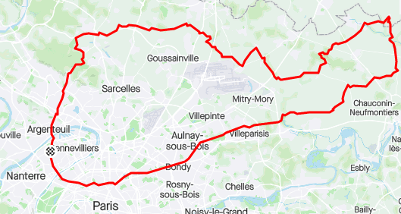

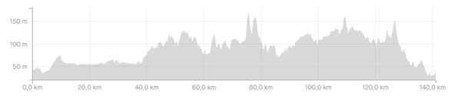

Trace Strava : [https://www.strava.com/routes/2822767447357025358](https://emea01.safelinks.protection.outlook.com/?url=https%3A%2F%2Fwww.strava.com%2Froutes%2F2822767447357025358&data=04%7C01%7C%7C6d3ee5808d32419e135408d90bab70ce%7C84df9e7fe9f640afb435aaaaaaaaaaaa%7C1%7C0%7C637553654379476299%7CUnknown%7CTWFpbGZsb3d8eyJWIjoiMC4wLjAwMDAiLCJQIjoiV2luMzIiLCJBTiI6Ik1haWwiLCJXVCI6Mn0%3D%7C1000&sdata=AnYg%2BXzsMcwXx%2BLvTLNStOyfC7Oti%2B1g91JWkhN4VnI%3D&reserved=0)

Trace Openrunner : [https://www.openrunner.com/r/12944286](https://emea01.safelinks.protection.outlook.com/?url=https%3A%2F%2Fwww.openrunner.com%2Fr%2F12944286&data=04%7C01%7C%7C6d3ee5808d32419e135408d90bab70ce%7C84df9e7fe9f640afb435aaaaaaaaaaaa%7C1%7C0%7C637553654379481276%7CUnknown%7CTWFpbGZsb3d8eyJWIjoiMC4wLjAwMDAiLCJQIjoiV2luMzIiLCJBTiI6Ik1haWwiLCJXVCI6Mn0%3D%7C1000&sdata=zR9k%2BOiMXGtSLGceLeVtbmWdqa1iJplsG5svYaV0FyM%3D&reserved=0)

# Parcours n°2 – Sortie club en Seine-et-Marne – 113 Km – 686 mètres de dénivelé

Colombes (vers Porte de Champerret) – La Garenne-Colombes – Courbevoie – Neuilly – Paris (vers Canal de l’Ourcq) – Piste cyclable du Canal de l’Ourcq – Gressy – Messy – Charny – Iverny – Cuisy (**côte de Cuisy – 1,56 Km à 3,3%)** – Montgé-en-Goële - Jully – Thieux – Villeneuve-sous-Dammartin – Moussy-le-Vieux – Le Mesnil-Amelot – Mauregard – Chennevières-lès-Louvres – Villeron – Puiseux-en-France – Châtenay-en-France – Mareil-en-France -Villiers-le-Sec – route en béton – Attainville – Moiselles – Montlignon – Eaubonne – Ermont – Sannois – Argenteuil – Colombes

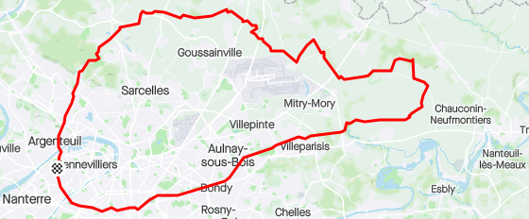

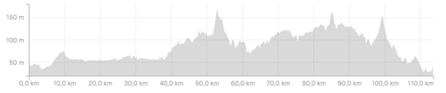

Trace Strava : [https://www.strava.com/routes/2822774821840808014](https://emea01.safelinks.protection.outlook.com/?url=https%3A%2F%2Fwww.strava.com%2Froutes%2F2822774821840808014&data=04%7C01%7C%7C6d3ee5808d32419e135408d90bab70ce%7C84df9e7fe9f640afb435aaaaaaaaaaaa%7C1%7C0%7C637553654379486247%7CUnknown%7CTWFpbGZsb3d8eyJWIjoiMC4wLjAwMDAiLCJQIjoiV2luMzIiLCJBTiI6Ik1haWwiLCJXVCI6Mn0%3D%7C1000&sdata=xMnbWph2UErZVizRWfUYVxtDs16e%2FuhKbJtEd04Bd38%3D&reserved=0)

Trace Openrunner : [https://www.openrunner.com/r/12944346](https://emea01.safelinks.protection.outlook.com/?url=https%3A%2F%2Fwww.openrunner.com%2Fr%2F12944346&data=04%7C01%7C%7C6d3ee5808d32419e135408d90bab70ce%7C84df9e7fe9f640afb435aaaaaaaaaaaa%7C1%7C0%7C637553654379491239%7CUnknown%7CTWFpbGZsb3d8eyJWIjoiMC4wLjAwMDAiLCJQIjoiV2luMzIiLCJBTiI6Ik1haWwiLCJXVCI6Mn0%3D%7C1000&sdata=%2BpaeD8r9xifMdwvqI8brphvjy6TcOq2j%2BfXfFOGQW3w%3D&reserved=0)

# Parcours n°3a : Sortie club en Seine-et-Marne – 85 Km – 628 mètres de dénivelé

Colombes – Argenteuil – Sannois – Ermont – Eaubonne – Montlignon (**Côte de Montlignon – 3,79Km à 2%)** – Moiselles – Attainville – Villers-le-Sec – Mareil-en-France – Châtenay-en-France – Puiseux-en-France – Villeron – Vémars – Moussy-le-Neuf (**Seine-et-Marne**) – Chennevières-lès-Louvres (Val d’Oise) - Villeron – Puiseux-en-France – Châtenay-en-France – Mareil-en-France -Villiers-le-Sec – route en béton – Attainville – Moiselles – Montlignon – Eaubonne – Ermont – Sannois – Argenteuil – Colombes

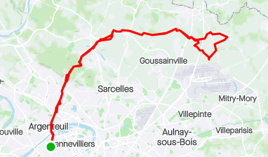

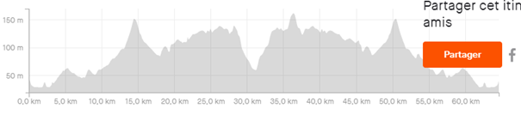

Trace Strava : [https://www.strava.com/routes/2822790838775075918](https://emea01.safelinks.protection.outlook.com/?url=https%3A%2F%2Fwww.strava.com%2Froutes%2F2822790838775075918&data=04%7C01%7C%7C6d3ee5808d32419e135408d90bab70ce%7C84df9e7fe9f640afb435aaaaaaaaaaaa%7C1%7C0%7C637553654379496209%7CUnknown%7CTWFpbGZsb3d8eyJWIjoiMC4wLjAwMDAiLCJQIjoiV2luMzIiLCJBTiI6Ik1haWwiLCJXVCI6Mn0%3D%7C1000&sdata=w7%2BLt431ZkTTP1LVV%2BS6E14XryHBJo1RFvVnKlG7bAM%3D&reserved=0)

Trace Openrunner : [https://www.openrunner.com/r/12958181](https://emea01.safelinks.protection.outlook.com/?url=https%3A%2F%2Fwww.openrunner.com%2Fr%2F12958181&data=04%7C01%7C%7C6d3ee5808d32419e135408d90bab70ce%7C84df9e7fe9f640afb435aaaaaaaaaaaa%7C1%7C0%7C637553654379501184%7CUnknown%7CTWFpbGZsb3d8eyJWIjoiMC4wLjAwMDAiLCJQIjoiV2luMzIiLCJBTiI6Ik1haWwiLCJXVCI6Mn0%3D%7C1000&sdata=gBdGHCr6m2jZLT%2BhlPY75RKeUfo9q5Xt9qGCqKMdX84%3D&reserved=0)

# Parcours n°3b – 85 Km – 513 mètres de dénivelé

Parcours créer par Pierre. Comporte peut-être une section (1Km) en chemin de terre vers Le Mesnil-Amelot (inévitable sauf gros détour de 10Km ou Passage par la RN104 (4voie limité à 110 Km/h et interdit en vélo)

Colombes (Vers Porte de Champerret) - La Garenne-Colombes - Courbevoie - Neuilly - Paris (vers Canal de l'Ourcq) - Piste Cyclable du Canal de l'Ourcq - Mitry-Mory - Le Mesnil-Amelot - Epiais-les-Louvres - Villeron - Puiseux-en-France - Châtenay-en-France - Fontenay-en-Parisis - Le Plessis-Gassot - Bouqueval - Villiers-le-Bel - Sarcelles - Deuil-la-Barre - Epinay-sur-Seine - Gennevilliers - Colombes

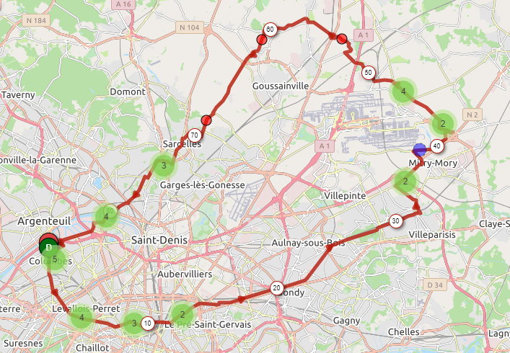

Trace Openrunner : <https://www.openrunner.com/r/12967195>

# Parcours n°4 – 65 Km – 535 mètres de dénivelé

Colombes – Argenteuil – Sannois – Ermont – Eaubonne – Montlignon (**Côte de Montlignon – 3,79Km à 2%)** – Moiselles – Attainville – Villers-le-Sec – Mareil-en-France – Jagny-sous-Bois – Lassy – Bellefontaine – Châtenay-en-France - Mareil-en-France -Villiers-le-Sec – route en béton – Attainville – Moiselles – Montlignon – Eaubonne – Ermont – Sannois – Argenteuil – Colombes

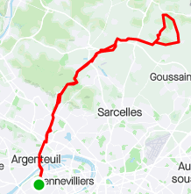

Trace Strava : [https://www.strava.com/routes/2822931587123183038](https://emea01.safelinks.protection.outlook.com/?url=https%3A%2F%2Fwww.strava.com%2Froutes%2F2822931587123183038&data=04%7C01%7C%7C6d3ee5808d32419e135408d90bab70ce%7C84df9e7fe9f640afb435aaaaaaaaaaaa%7C1%7C0%7C637553654379506161%7CUnknown%7CTWFpbGZsb3d8eyJWIjoiMC4wLjAwMDAiLCJQIjoiV2luMzIiLCJBTiI6Ik1haWwiLCJXVCI6Mn0%3D%7C1000&sdata=B3zucFCLZ8hA%2BsdkOU3ZwmqHinDQFzqyPIndeCGkt1w%3D&reserved=0)

Trace Openrunner : [https://www.openrunner.com/r/12958843](https://emea01.safelinks.protection.outlook.com/?url=https%3A%2F%2Fwww.openrunner.com%2Fr%2F12958843&data=04%7C01%7C%7C6d3ee5808d32419e135408d90bab70ce%7C84df9e7fe9f640afb435aaaaaaaaaaaa%7C1%7C0%7C637553654379511135%7CUnknown%7CTWFpbGZsb3d8eyJWIjoiMC4wLjAwMDAiLCJQIjoiV2luMzIiLCJBTiI6Ik1haWwiLCJXVCI6Mn0%3D%7C1000&sdata=3Ca983x5PKRp8eDK2gjXeXA1w0I%2B1%2Fwujt3LhnK41jM%3D&reserved=0)